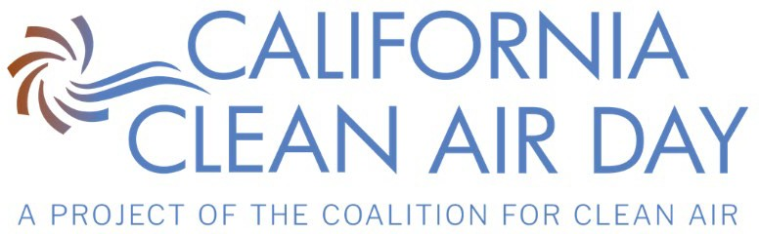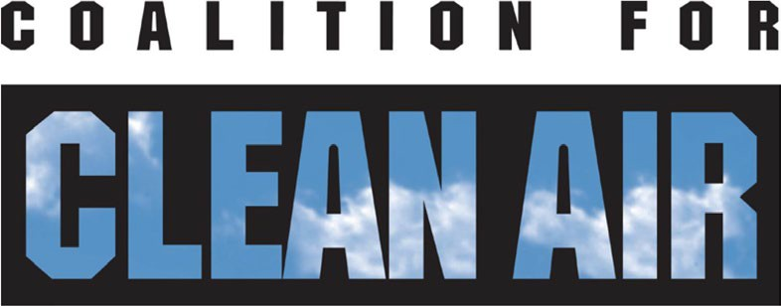

CA Clean Air Day Press Event | September 28, 2023
El Monte Union High School Bus Depot

List of Event Spokespersons

The following are available for interviews:
- Dr. Debra Duardo, Los Angeles County Superintendent of Schools

- Dr. Joe Lyou, CEO of Coalition for Clean Air

- Blanca Rodriguez, Deputy District Director of External Affairs, Caltrans

- Ricardo Padilla, Board President of El Monte Union High School District

- Dr. Edward Zuniga, Superintendent of El Monte Union High School District

- Lena Luna, Grant Lead, Clean Mobility in Schools Pilot Project and EMUHSD Facility & Energy Manager

- DeAdalene Olmedo, Mountain View High School senior and ASB President

- Kirk McGinnis, Director of Curriculum and Instruction, EMUHSD—developing Career Technical Education Modules about Clean Energy/Clean Transportation

- Lalo Alcaraz, the artist who created the Taking a Healthy Ride on the Green Side animations

- William Vargas, Transportation Coordinator, who manages the EMUHSD electric bus fleet and charging stations

- Richard Heilemann, South El Monte High School teacher, and students from the ETC (Environment to Climate) Action Club

Spokespersons can be identified with event name badges.

